SNMPWALK, LDAPSEARCH & BLOODHOUND – COMPREHENSIVE TECHNICAL DOCUMENTATION
Network Device & Active Directory Enumeration Tools for Ethical Hacking & Penetration Testing
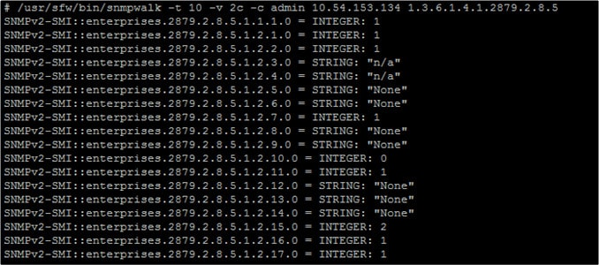
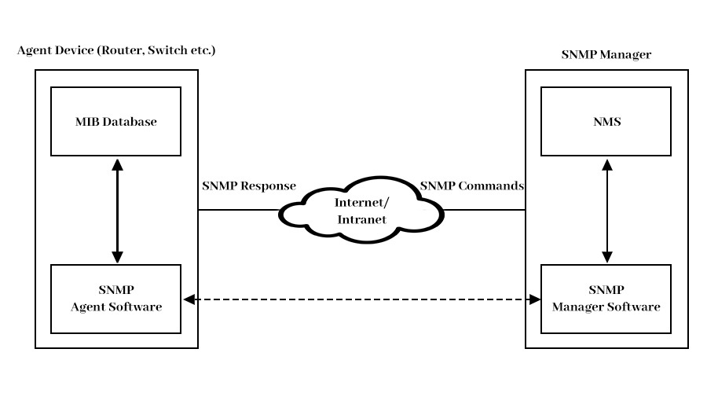
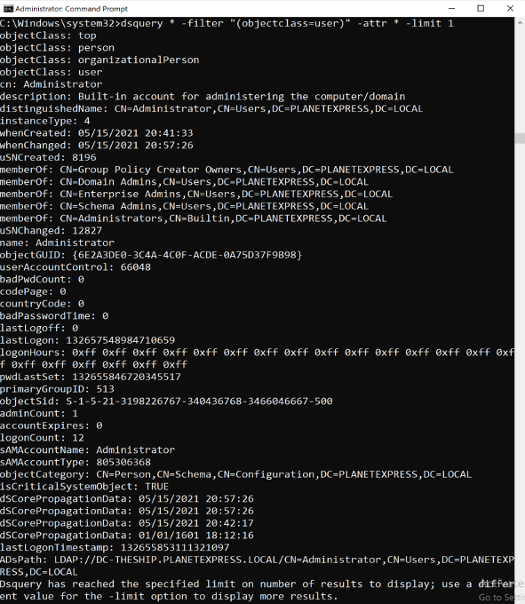
4

ABSTRACT
Modern enterprise environments rely heavily on network devices and directory services such as SNMP-managed infrastructure and Active Directory (AD). Misconfigurations in these services often lead to severe information disclosure and privilege escalation opportunities. This document presents a comprehensive technical study of SNMPWALK, LDAPSEARCH, and BLOODHOUND, three critical enumeration tools used in penetration testing. The report explains theoretical foundations, internal working mechanisms, command usage, practical case studies, advantages, limitations, and defensive considerations. The objective is to provide an academic and practical understanding suitable for cybersecurity coursework, lab records, interviews, and professional security assessments.

PART A: SNMPWALK TOOL


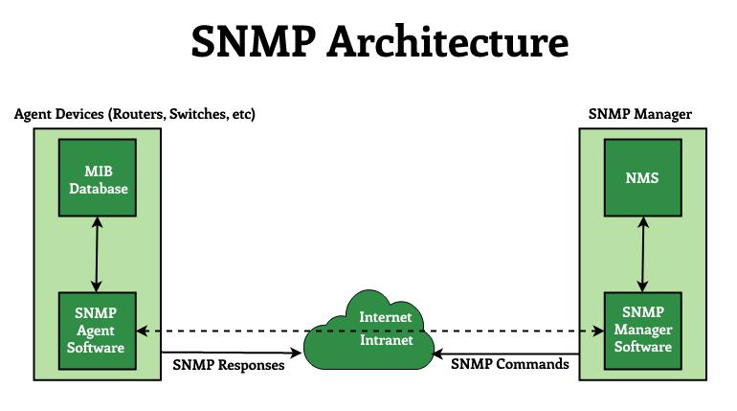

1. INTRODUCTION TO SNMPWALK
Simple Network Management Protocol (SNMP) is widely used to manage and monitor network devices such as routers, switches, printers, servers, and IoT devices. SNMP allows administrators to retrieve device status, configurations, and performance metrics.
From a security perspective, SNMP becomes dangerous when default or weak community strings (such as public or private) are enabled. Attackers can exploit this to extract sensitive information remotely.
SNMPWALK is a command-line tool that systematically queries SNMP Object Identifiers (OIDs) to retrieve extensive device information.

2. OBJECTIVE OF USING SNMPWALK
The objectives of SNMPWALK are:
- To enumerate network devices using SNMP
- To retrieve system, interface, and process details
- To identify exposed configurations and credentials
- To support lateral movement planning
SNMPWALK is commonly used in the Enumeration phase of penetration testing.

3. WORKING MECHANISM OF SNMPWALK
SNMPWALK communicates with SNMP agents over UDP port 161. Using a community string (v1/v2c) or credentials (v3), it recursively queries the SNMP tree starting from a base OID.
If access is permitted, SNMPWALK returns:
- Device name and OS
- Network interfaces
- Routing tables
- Running processes
- Installed software

4. COMMAND USAGE AND ANALYSIS (SNMPWALK)
4.1 Basic SNMP Enumeration
snmpwalk -v2c -c public 192.168.1.10

4.2 Enumerate System Information
snmpwalk -v2c -c public 192.168.1.10 1.3.6.1.2.1.1

4.3 Enumerate Network Interfaces
snmpwalk -v2c -c public 192.168.1.10 1.3.6.1.2.1.2

4.4 Enumerate Running Processes
snmpwalk -v2c -c public 192.168.1.10 1.3.6.1.2.1.25.4.2.1.2

5. PRACTICAL CASE STUDY (SNMPWALK)
Scenario
A tester identifies UDP port 161 open on a network device.
Execution
snmpwalk -v2c -c public 192.168.146.1
Observations
- Retrieved router hostname and OS version
- Enumerated network interfaces and IPs
- Identified running services
Impact
Sensitive infrastructure details were exposed, enabling targeted exploitation and lateral movement.

6. ADVANTAGES & LIMITATIONS (SNMPWALK)
Advantages
- Extremely detailed information
- Effective against misconfigured devices
- Low interaction cost
Limitations
- Requires valid community string
- SNMPv3 is harder to enumerate
- UDP-based, may be filtered

PART B: LDAPSEARCH TOOL
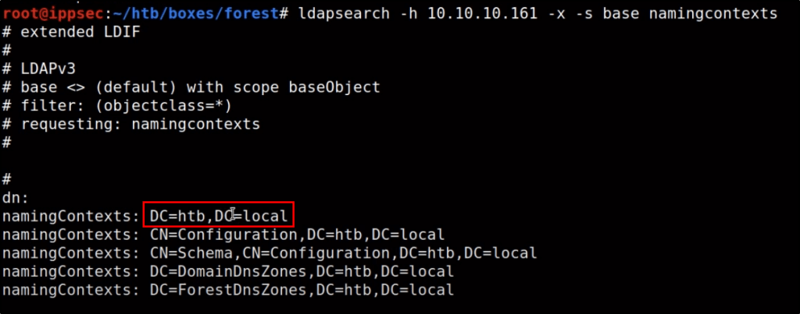
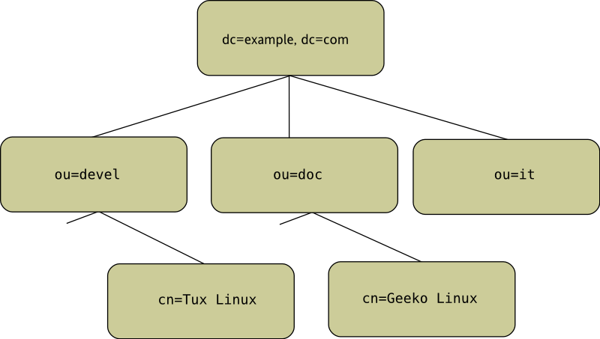
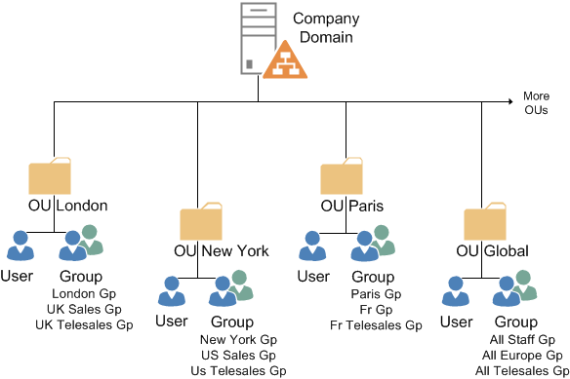

7. INTRODUCTION TO LDAPSEARCH
Lightweight Directory Access Protocol (LDAP) is the backbone of directory services such as Microsoft Active Directory. It stores information about users, groups, computers, and permissions.
LDAPSEARCH is a command-line utility used to query LDAP directories directly. In penetration testing, it is often used to enumerate AD objects anonymously or with valid credentials.

8. OBJECTIVE OF USING LDAPSEARCH
LDAPSEARCH is used to:
- Enumerate users and groups
- Identify organizational units (OUs)
- Discover password and policy settings
- Gather data for privilege escalation
LDAPSEARCH is typically used during Active Directory Enumeration.

9. WORKING MECHANISM OF LDAPSEARCH
LDAPSEARCH connects to the LDAP service (TCP 389 or 636 for LDAPS) and executes directory queries using filters and base distinguished names (DNs).
Depending on permissions, LDAPSEARCH can retrieve extensive directory data without triggering alerts.

10. COMMAND USAGE AND ANALYSIS (LDAPSEARCH)
10.1 Anonymous LDAP Query
ldapsearch -x -h 192.168.1.20 -b "dc=example,dc=com"

10.2 Enumerate Users
ldapsearch -x -h 192.168.1.20 -b "dc=example,dc=com" "(objectClass=user)"

10.3 Enumerate Groups
ldapsearch -x -h 192.168.1.20 -b "dc=example,dc=com" "(objectClass=group)"

11. PRACTICAL CASE STUDY (LDAPSEARCH)
Observations
- Enumerated domain users
- Identified privileged groups
- Retrieved domain structure
Impact
Provided critical input for credential attacks and privilege escalation paths.

PART C: BLOODHOUND TOOL
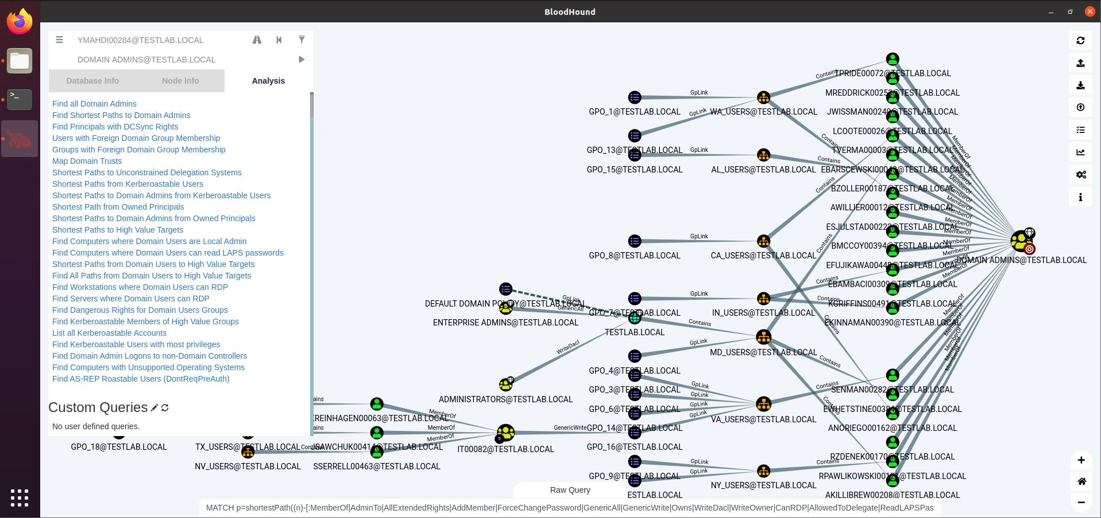
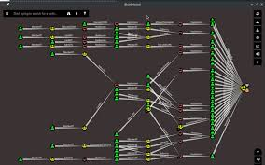
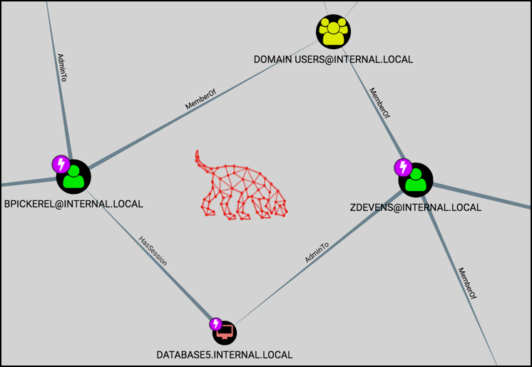

12. INTRODUCTION TO BLOODHOUND
BloodHound is an advanced Active Directory enumeration and attack path visualization tool. It analyzes AD relationships using graph theory to identify complex privilege escalation paths that are difficult to detect manually.
BloodHound is widely used by red teams and blue teams to understand AD security posture.

13. WORKING MECHANISM OF BLOODHOUND
BloodHound operates in two stages:
- Data Collection
Collectors (SharpHound / BloodHound-Python) gather AD data.
- Graph Analysis
Data is ingested into a Neo4j graph database and visualized.
BloodHound reveals attack paths such as:
- Kerberoasting paths
- ACL abuses
- Delegation misconfigurations

14. COMMAND USAGE AND ANALYSIS (BLOODHOUND)
14.1 Data Collection (Linux)
bloodhound-python -u user -p password -d example.com -c All

14.2 Launch BloodHound Interface
bloodhound

15. PRACTICAL CASE STUDY (BLOODHOUND)
Observations
- Identified shortest path to Domain Admin
- Discovered ACL-based privilege escalation
- Visualized trust relationships
Impact
BloodHound exposed critical AD misconfigurations enabling full domain compromise.

16. COMPARISON: SNMPWALK vs LDAPSEARCH vs BLOODHOUND
Tool | Focus Area | Best Use Case
SNMPWALK | Network devices | Infrastructure enumeration
LDAPSEARCH | Directory queries | Raw AD enumeration
BloodHound | Graph analysis | AD attack path discovery

17. SECURITY & DEFENSIVE CONSIDERATIONS
Organizations should:
- Disable default SNMP community strings
- Restrict anonymous LDAP access
- Monitor directory queries
- Regularly analyze AD attack paths

18. LEGAL & ETHICAL CONSIDERATIONS
These tools must only be used with explicit authorization. Misuse can result in serious legal and organizational consequences.

19. CONCLUSION
SNMPWALK, LDAPSEARCH, and BloodHound are indispensable tools for network and Active Directory enumeration. While SNMPWALK targets infrastructure devices, LDAPSEARCH and BloodHound focus on directory services and privilege relationships. Mastery of these tools enables cybersecurity professionals to understand, exploit, and defend complex enterprise environments effectively.

20. REFERENCES
- SNMP RFCs (1157, 3411)
- LDAP Protocol Documentation
- Active Directory Security Guides
- OWASP Testing Guides

